User Manual

Program overview 2

Navigating the program 2

The Patient Module 4

Overview 4

Edit Patient Screen 6

Remove Patient Screen 7

View Patient Screen 8

List All Patients Screen 9

GP Screen 10

Overview 10

Add New Doctor Screen 11

Edit Doctor Screen 12

Appointment Module 13

Overview 13

Add New Appointment Screen 14

View Appointment 15

Print Daily Appointment List Module 16

Trouble Shooting 17

The program crashes 17

My file cant be found 17

The program freezes 17

# **Program** overview

Welcome to the Shaw Medical Center all in one program.

This program will allow you to manage patients, doctors and appointments.

The patient module allows you to create new patients, edit their details later if needed, view a patients details and list all patients in the system.

The doctor module allows you to create new doctors and edit their details if needed.

The appointment module allows you to create new appointments and view an appointments details. You can also list all booked times within the program.

# Navigating the program

Upon first loading the program you will be greeted by a screen like this:

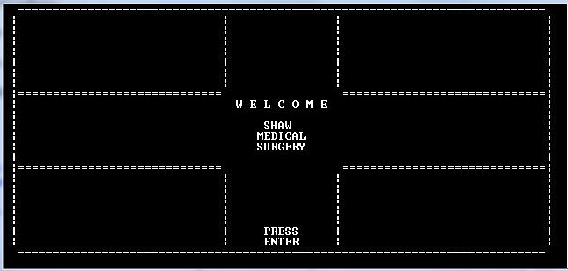

Simply press enter to proceed to this screen:

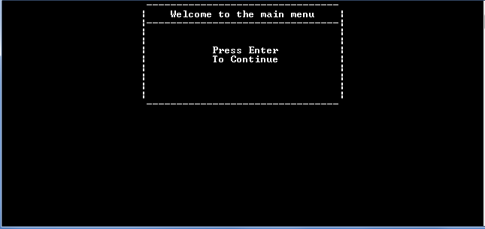

Press enter again and the main menu will load up like so:

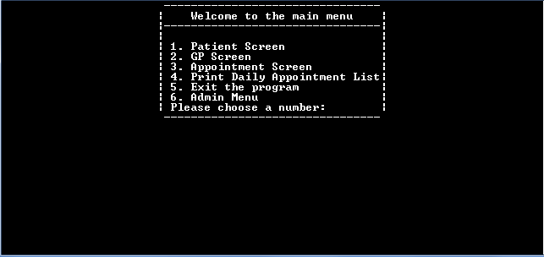

To enter a module simply enter the number of the module you wish to use, i.e

* Patient module is 1
* Doctor module is 2
* Appointment module is 3.

When the program asks for a number remember to put in the actual number and not the word, i.e. Use 2 not two. Sometimes you will have to press enter to confirm your choice and sometimes the program will immediately respond, an easy way to know is just to press the number, if the number appears on screen then press enter and you will proceed.

The only other type of navigation you will encounter is when the program will either ask you for a y or n answer. In these cases y means yes and n means no, simply press the appropriate answer and the program will proceed.

If you find yourself in a menu or option you do not want to be in there is an easy way to exit. If in a menu with a number choice simply enter a number outside the listed range, i.e if in the patient menu type 7 and press enter, you will be returned to the main menu. If in a screen like the edit patient screen where you simply have to press a number press a number outside the accepted range like 9 and you will skip editing any details and have the option to leave the screen.

If the program ever seems to hang for longer then a couple of seconds simply press enter and it will pick up again.

# The Patient Module

## Overview

The patient module is split into five parts:

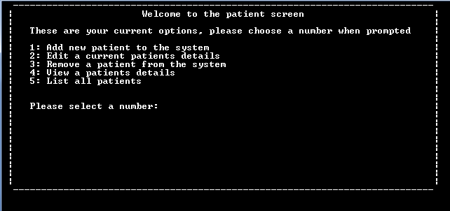

1. The Add Patient screen
2. The Edit Patient screen
3. The Remove patient screen
4. The View Patient screen
5. The List all patients screen

Add Patient Screen

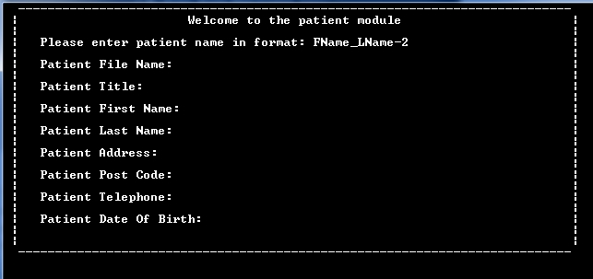

To add a new patient simply follow the format it asks for up top in the red box, i.e if it asks for FName_LName-2 enter something like John_Smith-2, or if it asks for FName_LName-5 enter Eric_Jones-5.

The red box is known as the info screen and is common among most of the screens in the program, this is where important information will be displayed so pay attention to it.

To enter a new patient simply enter the file name in the format described above and press enter.

The program will then proceed to the next field with a flashing cursor showing where you are up to. Simply enter the detail for that field and press enter, do this for all fields and you will eventually reach a point like this:

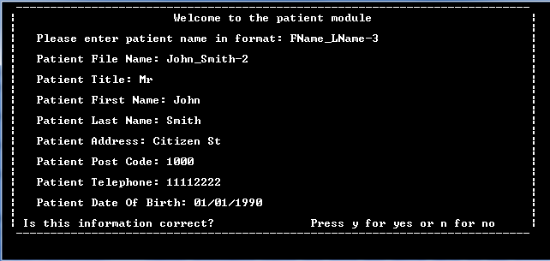

If the information you entered is correct press y and it will be saved, if not press n and you will be given the chance to restart and enter the details again.

## Edit Patient Screen

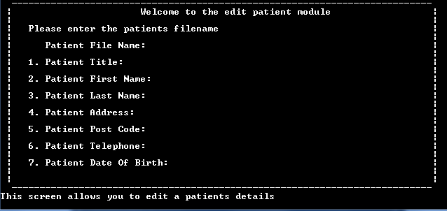

The edit patient screen is very similar to the add patient screen. To edit a patient simply enter their filename and it will load up their details like so:

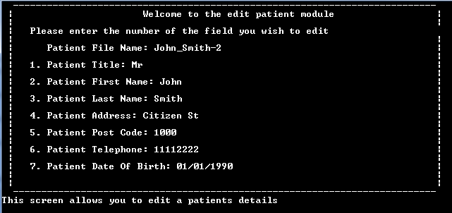

If entering a filename returns an error it is likely that either you entered the filename wrong or the patient doesn't exist, so just try again when instructed to. If the problem persists contact your administrator.

Once the patients details are loaded you will be asked to enter a number. Unlike the add patient screen these fields are numbered so simply enter the number of the field you wish to edit and then enter the amended detail, press enter and the detail will be saved. If you then wish to edit another field press y and you will be able to, otherwise press n and you can return to the main menu. Please note that the filename is not editable. To exit this screen without editing anything press a number outside of the range like 9.

## Remove Patient Screen

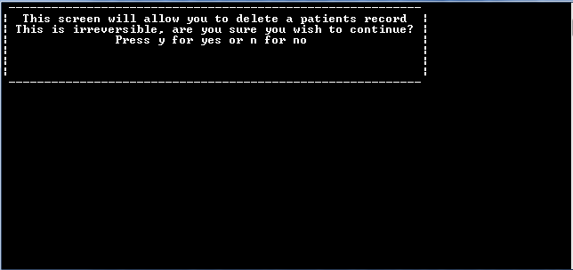

Upon entering the remove patient screen you will will be greeted by the above, read it carefully and make sure you really want to remove a patient as this is irreversible. If you wish to continue press y and you will reach this screen:

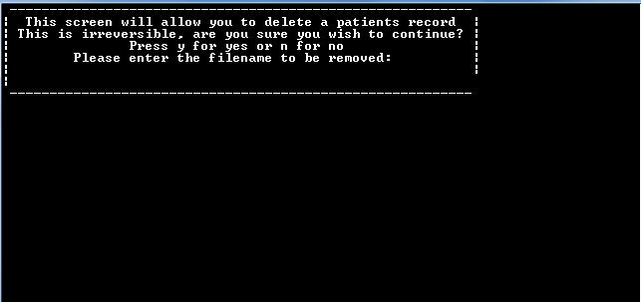

Simply enter the filename of the patient to be removed and press enter, the file will then be deleted and you will be able to return to the main menu.

## View Patient Screen

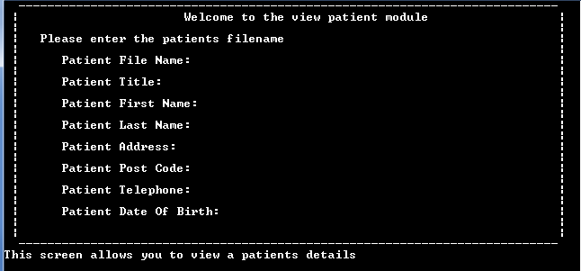

This screen allows you to view a patients details, simply enter the filename of the patient you wish to view and all the details will load like so:

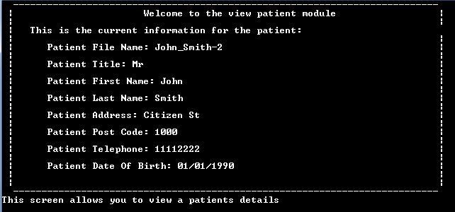

Simply press enter when you are ready to leave

## List All Patients Screen

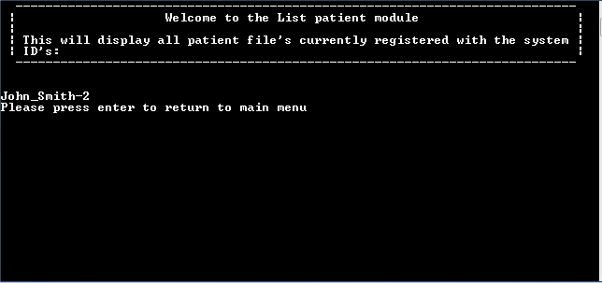

This screen does not require any major user input and will automatically display all patients registered with the system, The screen will only display five files at once so to view more just press enter to go to the next page. When all pages have been viewed you will be able to return to the main menu

# GP Screen

## Overview

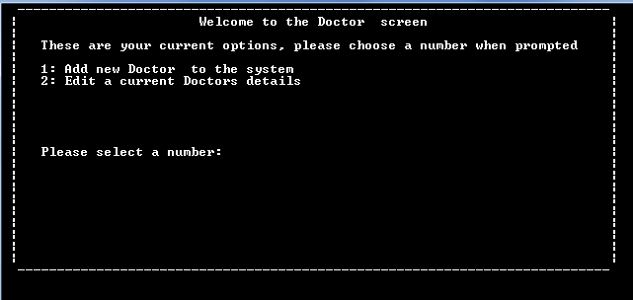

The GP screen allows you to manage all the doctors in the system by adding new ones or editing existing ones.

## Add New Doctor Screen

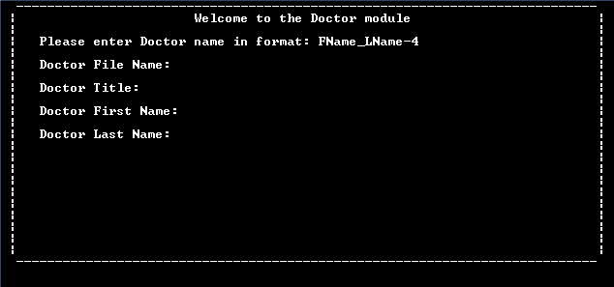

This screen is much like the add new patient screen. To use it simply enter the filename in the format requested and then press enter to proceed to the next field and enter the relevant details, when all fields have been filled in you will see this screen:

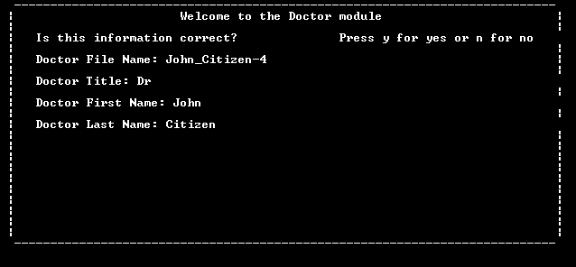

If all the entered details are correct press y and the file will save, if not press n and you will get to enter the details again.

## Edit Doctor Screen

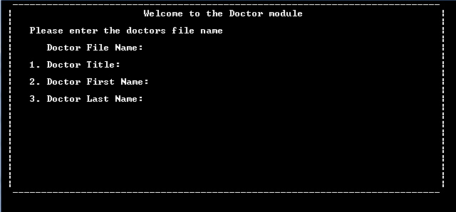

This screen is very similar to the edit patient screen, to use simply enter the doctors filename and their details will load like so:

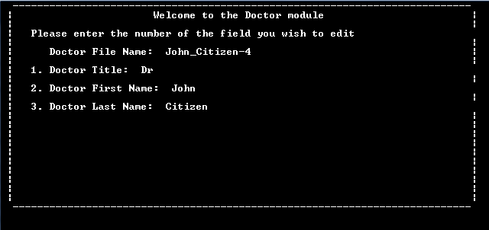

To edit a field simply press the number for the desired field and then type in the new value. Then press enter and the new value will be saved. If you wish to edit another field then press y when asked, otherwise press n and you will be able to return to the the main menu.

# Appointment Module

## Overview

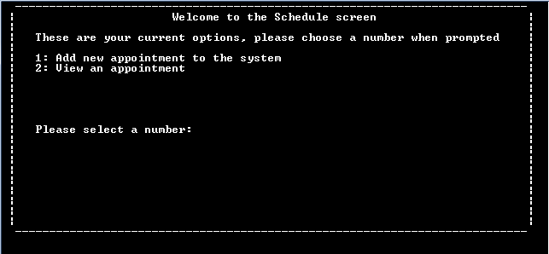

This module allows you to add a new appointment or view the details of an existing one, for a printout of all currently booked appointments go back to the main menu and select print daily appointment list.

To add a new appointment select option one, to view an existing appointment select option two.

## Add New Appointment Screen

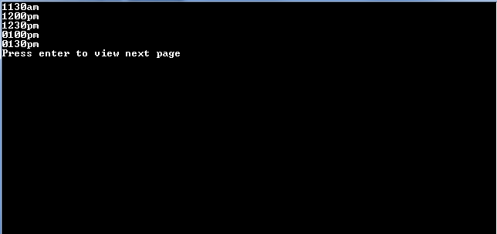

When you select the add new appointment screen you will be greeted by this screen. This screen lists all the available times but will only display five at a time, to see the rest press enter to view the next page, after all pages have been viewed you will be asked to enter a time. Simply enter the desired available time in the format xxxx00 i.e 0430pm or 1100am.

You will then be asked for the filename of the patient having the appointment, simply enter the filename and then press enter. Once a valid file is entered you will be asked for the filename of the doctor with whom the appointment is, simply enter the filename and press enter. Once a valid file is entered the details will load like so:

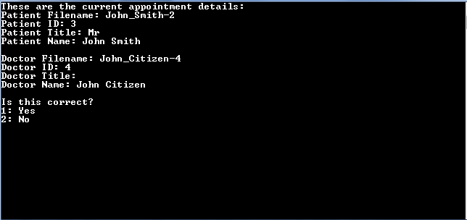

If all the details are correct type 1 and press enter and the appointment will be saved, otherwise type 2 and press enter and you will be able to re enter the details.

## View Appointment

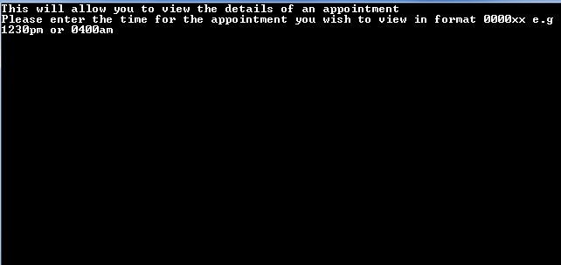

When you load the view appointment module you will be greeted by this screen. To view an appointment simply enter a time in the format requested and the details will load up like so:

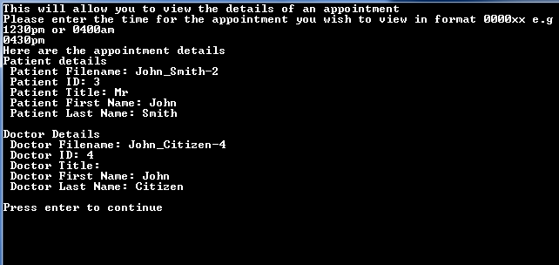

When you are ready to continue press enter and you will be taken back to the main menu.

# Print Daily Appointment List Module

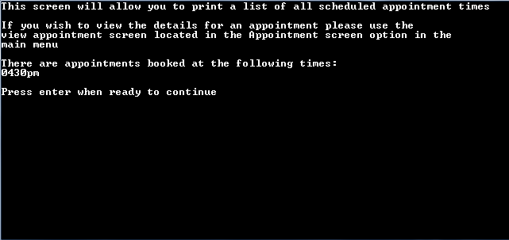

When you select the print daily appointment list the program will automatically retrieve the list of booked appointments and display them. When you are ready to continue simply press enter and you will be taken back to the main menu.

# Trouble Shooting

## The program crashes

If the program crashes it is likely you entered something invalid. Points to keep in mind is that when selecting a choice only use numbers not words unless it asks you for either y or n. Also keep your entries to a reasonable length, as a rule of thumb they should never exceed the end of the line.

## My file can’t be found

This is normally because you entered the filename wrong so try again and double check your entries. However if this persists and you are sure you got the filename right contact an administrator who will check to see that the file hasn’t accidentally been deleted.

If the program detects it can’t find a file it will tell you such and ask you for the filename again, double check your entry and try again. If after several attempts the file still cant be found you will be returned to the main menu.

## The program freezes

If the program has frozen check the screen for info asking you to enter something, otherwise just press enter and it should proceed. If this still doesn’t work close the program and reopen it, if it froze while you were in the middle of adjusting a file or something else important contact an administrator who will try and salvage what you were doing.